BBY'S FIRST ELF

This is a basic Buffer overflow problem. The first step checking the file type, we get a 32-bit, non-stripped Binary file.

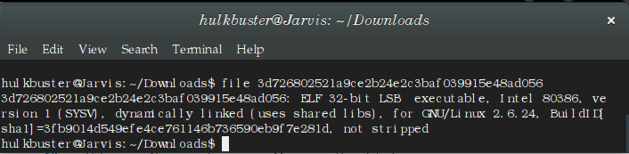

We first debug the binary using GDB debugger. When overflowed look for EBP and ESP to determine the stack size. We then checked for raw symbols of this object file. It is found a function "print_flag" with a memory address 0x0804856d.

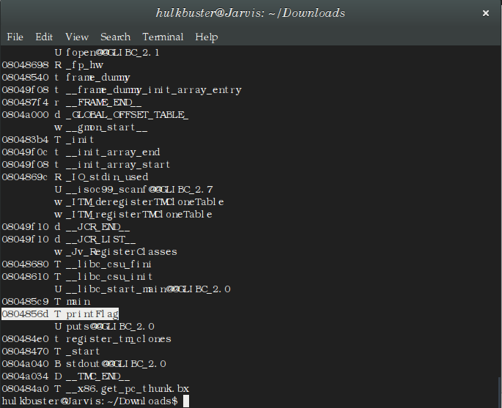

Thus the vulnerability is found and is exploited by over flowing (input more than the stack size) it to the address of "print_flag" function.

Note: The payload passed should be in little-endian format for this 32-bit system.

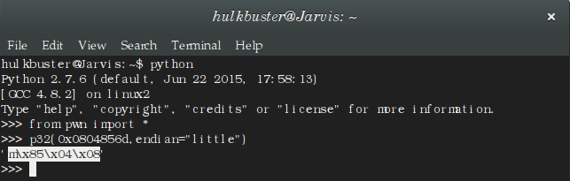
Thus the above payload reveals the flag for this challenge.

python -c 'print "m\x85\x04\x08"*40' | ./3d726802521a9ce2b24e2c3baf039915e48ad056.

Regards
TEAM BYTEBANDITS

